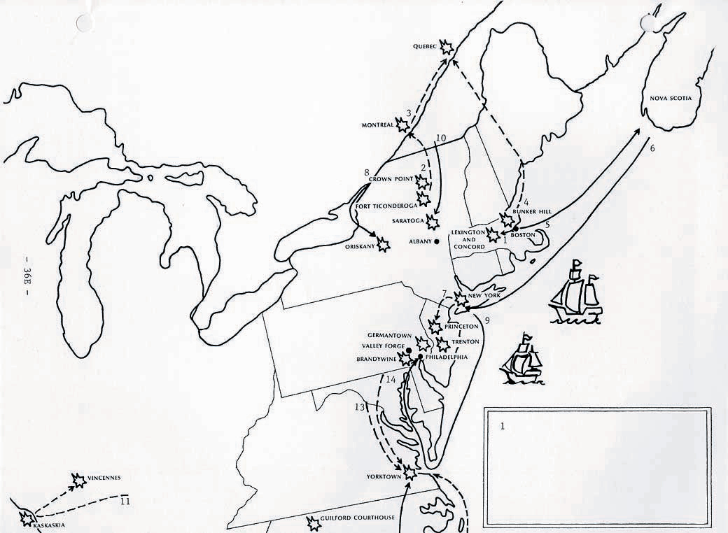v
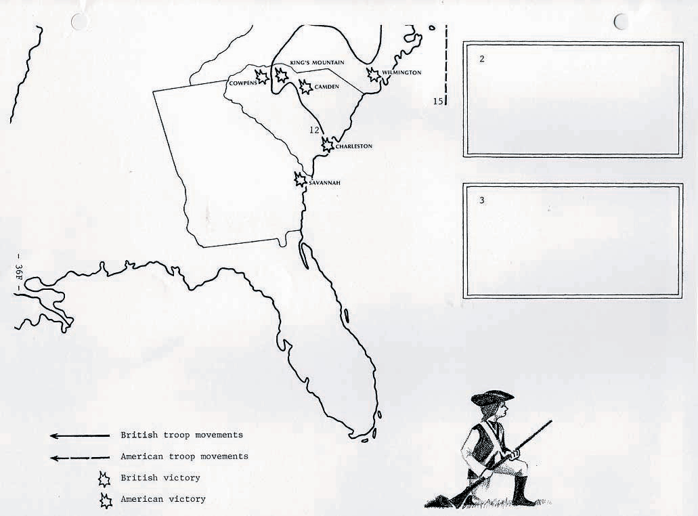

Directions for Mapwork
- Place the two map sections in front of you on your desk.
- Read the description of the Battles of Lexington and Concord on the chart below.
- Do the mapwork. Start by setting up a key in the lower left-hand corner of your map. The solid arrow represents British troop movements. Trace over this arrow with a colored pencil, marker, pen, or lead pencil. Use the same pencil, marker, or pen to fill in the battle symbol in the key that will represent a British victory on the map. Find the dotted arrow in the key that represents American troop movements. Trace over the arrow with a different colored pencil, marker, or pen. Shade in the battle symbol that will show an American victory.
- Throughout the map exercise, use the same color for all British troop movements (the solid arrows) and British victories (the battle symbols). Use the second color for all American troop movements (dotted arrows) and victories (battle symbols).
- When printing information on the map, always use small letters.

Battles of Lexington and Concord
General Thomas Gage ordered British troops to Lexington to try to capture Samuel Adams and John Hancock, and to Concord where the colonists had stored arms and ammunition. Revere, Dawes, Prescott warned the minutemen that the redcoats were coming. Adams and Hancock escaped from Lexington, but the British destroyed military stores at Concord. After the skirmishes at Lexington and Concord, the British marched back to Boston under a steady fire from the minutemen. The redcoats suffered heavy casualties.
On the map:
- Trace Arrow 1 (British) from Boston to Lexington and Concord.
- Print Apr. 1775 next to Lexington and Concord.
- Color the battle symbol to represent an American victory.

Battle of Bunker Hill
Following the battles of Lexington and Concord, the British returned to Boston. Some 10,000 colonial militiamen took up positions around the city. When the Americans occupied Breed's Hill, the redcoats attempted to drive them off. The first two British attacks failed, but the third assault on the hill succeeded when the Americans ran out of ammunition. The British won the battle, but lost far more soldiers than the patriots. The patriots displayed skill and courage, and showed that they would not be easily defeated.
On the map:
- Print June 1775 next to Bunker Hill.
- Color the battle symbol to represent a British victory.

Invasion of Canada
Ethan Allen and the Green Mountain Boys of Vermont, with the help of Benedict Arnold, captured the British forts at Ticonderoga and Crown Point. These successes in northern New York opened the way for a two-pronged invasion of Canada. The Americans hoped they could win the assistance of French-Canadians who disliked the British. American commander Richard Montgomery led an expedition north to Montreal, which he captured. Montgomery then advanced to Quebec where he joined forces with Benedict Arnold, who had marched north from Boston. The Americans attacked Quebec during a blizzard on December 31, 1775, but were driven back. Montgomery was killed and Arnold was seriously wounded. The Americans retreated to Fort Ticonderoga.
On the map:
- Next to forts Ticonderoga and Crown Point, print Ethan Allen/Green Mountain Boys. Color the battle symbols to represent American victories, and print May 1775.
- Trace Arrow 2 (Americans) from Fort Ticonderoga to Montreal. Print Montgomery next to the arrow, and Nov. 1775 next to Montreal.
- Color the battle symbol at Montreal to represent an American victory.
- Trace Arrow 3 to Quebec and print Montgomery next to it.
- Trace Arrow 4 from Boston to Quebec and print Arnold next to it.
- Color the battle symbol at Quebec to represent a British victory.
- Print Dec. 1775 next to Quebec.

The British Withdraw from Boston
Two weeks after the Battle of Bunker Hill, General George Washington took command of the Continental Army in Boston. Cannon taken at Fort Ticonderoga were positioned on Dorchester Heights overlooking Boston Harbor. Fearing the cannon, British general William Howe, who had replaced General Gage, withdrew from Boston to Nova Scotia, Canada. Five months later. General Howe landed on Long Island with the intention of capturing New York City. He was met by General Washington, who had moved the Continental Army south from Boston.
On the map:
- Trace Arrow 5 from Boston to Nova Scotia and print Howe next to it.
- Trace Arrow 6 to show the movement of British forces from Nova Scotia to Long Island. Print Howe next to it.

The British Capture New York City
Over the next four months, the British army won the battles of Long Island, New York, and White Plains. General Howe's powerful forces overwhelmed the smaller and poorly equipped American army. Howe missed several chances to pursue and destroy the retreating Americans. General Washington, using all of his skill as a commander, managed to escape into New Jersey. It was during the New York campaign that Nathan Hale was captured and hung as a spy on orders from General Howe.
On the map:
- Color the battle symbol to represent the British victories at Long Island, New York, and White Plains. Print Oct. 1776 next to the battle symbol.
- Print Nathan Hale next to New York.

Battles of Trenton and Princeton
New York City was now in the hands of the British. The ragged Continental Army was on the verge of defeat. Even Washington, retreating with his shoeless army through the cold winter rain, told a friend, "The spirits of the people have shrunk. Without fresh troops, I think the game is pretty near up." Thomas Paine wrote in his pamphlet "The Crisis" that, "These are the times that try men's souls." Washington struck back with two swift triumphs. Crossing the icy Delaware River on Christmas night, he surprised a large Hessian force at Trenton, New Jersey. A week later, he took Princeton. These victories boosted American spirits and attracted more men into the Continental Army.
On the map:
- Trace Arrow 7 to show Washington's retreat through New Jersey and subsequent attacks on Trenton and Princeton. Print Washington next to the arrow.
- Color the battle symbols at Trenton and Princeton to represent American victories.
- Print Dec. 1776 next to Trenton and Jan. 1777 next to Princeton.

Battles of Oriskany and Saratoga
The British, in 1777, planned to divide New England from the other colonies by capturing New York State. The plan had three parts: (1) General John Burgoyne was to march from Canada to Albany, New York. (2) Colonel Barry St. Leger was to lead an army from Canada to Oswego, and then eastward to Albany. (3) General William Howe would move north from New York City to Albany. But the British plan failed. St. Leger was defeated at the Battle of Oriskany. Instead of marching north to Albany, General Howe moved his army to Philadelphia, winning battles at Brandywine and Germantown against General Washington. General Burgoyne was defeated at the Battle of Saratoga by American forces commanded by General Horatio Gates. The news of the American victory at Saratoga convinced France to sign the Treaty of Alliance with the United States.
On the map:
- Trace Arrow 8 to Oriskany. Print St. Leger next to it. Color the battle symbol to represent an American victory. Print Aug. 1777 next to Oriskany.
- Trace Arrow 9 from New York City to Philadelphia. Print Howe next to it. Color the battle symbols at Brandywine (Sept. 1777) and Germantown (Oct. 1777) to represent British victories. Put the dates on the map.
- Trace Arrow 10 to Saratoga. Print Burgoyne next to it. Color the battle symbol to represent an American victory. Print Oct. 1777. Put Gates, the American commander, next to the battle symbol.

The British Leave Philadelphia
The redcoats spent the winter of 1777-1778 in Philadelphia, the capital of the United States. The city had fallen into British hands after the battles of Brandywine and Germantown. Meanwhile, the Continental Army set up winter head- quarters at nearby Valley Forge. Washington's men suffered from a shortage of food, clothing, and other supplies. Baron von Steuben reorganized and trained the Continentals to prepare them for the military campaigns of 1778. By May, large-scale French aid, including an army and a powerful fleet, began arriving in the United States. Feeling increased pressure. General Henry Clinton, who succeeded Howe, abandoned Philadelphia and moved British forces back to New York City.
On the map:
- Print Washington/Baron von Steuben: winter 1778 next to Valley Forge, Pennsylvania.
- In box 1 along the right side of the map, print May 1778: Congress ratifies the Treaty of Alliance with France.

George Rogers Clark Conquers the Northwest
During the war, the British encouraged their Indian allies to attack American settlers on the western frontier. To end these raids, George Rogers Clark led a band of frontiersmen into the present-day states of Illinois and Indiana. Clark's men captured the British forts at Kaskaskia and Vincennes.
On the map:
- Trace Arrow 11 and print Clark next to it.
- Color the battle symbols at Kaskaskia and Vincennes to represent American victories.
- Print July 1778 next to Kaskaskia.
- Print Feb. 1779 next to Vincennes.

The War at Sea
Throughout the Revolutionary War, American naval forces tried to avoid a direct confrontation with the powerful British Navy. Instead, they concentrated on disrupting Great Britain's trade. The small Continental Navy, with the help of about 2,000 privateers, inflicted heavy damage on British shipping. About 800 British ships were captured or destroyed. The most famous battle involved the "Bonhomme Richard," commanded by Captain John Paul Jones, and the British warship "Serapis." The Americans captured the 44-gun "Serapis" after a bloody, bitter fight off the coast of Great Britain.
On the map:
- In box 2 along the right side of the map, print Sept. 1779: John Paul Jones captures the "Serapis."
- In the Atlantic Ocean, color the largest ship to represent British naval forces. Next to it print British Navy.
- Color the smaller ship to represent American naval forces. Next to it print Continental Navy/privateers.

The End of the War
Most of the fighting in the last years of the war took place in the South. The British captured the coastal cities of Savannah, Charleston, and Wilmington. The British army, under General Charles Cornwallis, marched inland and defeated American forces at Camden, South Carolina. But Washington, who was containing General Clinton in New York, sent General Nathanael Greene to the southern states. After the Continental Army won battles at King's Mountain, Cowpens, and Guilford Courthouse, Cornwallis retreated to the coast. He marched his army to Yorktown, Virginia, which he planned to use as a base of operations. As Marquis de Lafayette occupied Cornwallis, Washington hurried south from New York with a force of 20,000 men. Meanwhile, a French fleet under Admiral de Grasse prevented the British Navy from rescuing Cornwallis. Surrounded on all sides and under a savage bombardment, Cornwallis surrendered. Yorktown was the last major battle of the war. In the Treaty of Paris, Great Britain recognized the independence of the United States.
On the map:
- Color the battle symbols at Savannah (Dec. 1778), Charleston (May 1780), Camden (Aug. 1780), and Wilmington (Feb. 1781) to represent British victories. Print the dates on the map.
- Color the battle symbols at King's Mountain (Oct. 1780), Cowpens (Jan. 1781), and Guilford Courthouse (Mar. 1781) to represent American victories. Print the dates on the map.
- Arrow 12 shows Cornwallis' march through the South. Trace the arrow from Charleston to Yorktown, and print Cornwallis next to it.
- Print Greene next to Guilford Courthouse.
- Trace Arrow 13 and print Lafayette next to it.
- Trace Arrow 14 and print Washington next to it.
- Trace Arrow 15 and print Admiral de Grasse next to it.
- Color the battle symbol at Yorktown to represent an American victory. Print Oct. 1781 next to it.
- In box 3, print Sept. 1783: The United States and Great Britain sign the Treaty of Paris.

