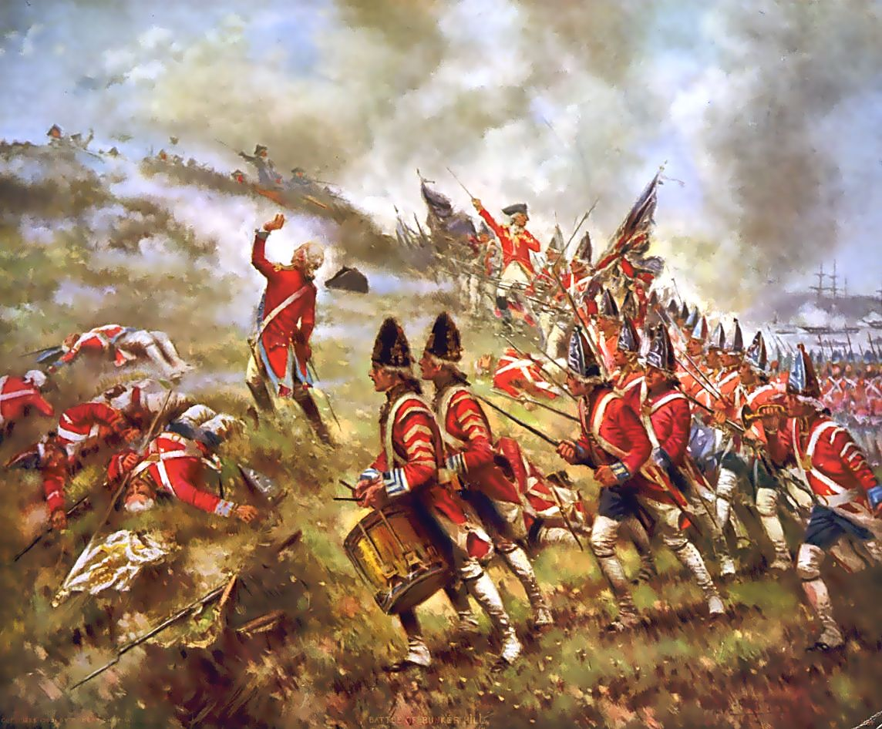

Battles of the Revolution!
US History I
Mr. Collison

Overview: There were many important battles of the Revolutionary War that benefitted both sides and changed the tide of the War. Working with a partner, (EACH OF YOU NEED TO TYPE YOUR OWN PAPER UP) you are going to be researching some of these influential battles. Using AT LEAST TWO websites (Not Wikipedia!,) you are going identify the major people, location, casualties, and overall impact of the battles on the rest of the war.

Do Not Copy/Paste

Below you will find the major battles you are going to research and the information you need to identify using various online sources.
Battle of Trenton:

Location:

Leaders for both sides:

Casualties:

Details of the Battle (What happened?):

Impact of the Battle on the Revolution:

Battle of Saratoga:

Location:

Leaders for both sides:

Casualties:

Details of the Battle (What happened?):

Impact of the Battle on the Revolution:

Battle of Kings Mountain:

Location:

Leaders for both sides:

Casualties:

Details of the Battle (What happened?):

Impact of the Battle on the Revolution:

Battle of Yorktown:

Location:

Leaders for both sides:

Casualties:

Details of the Battle (What happened?):

Impact of the Battle on the Revolution:

