Name ___________________________________________ Date ______________ Period ________________

The Berlin Crisis and East Asia

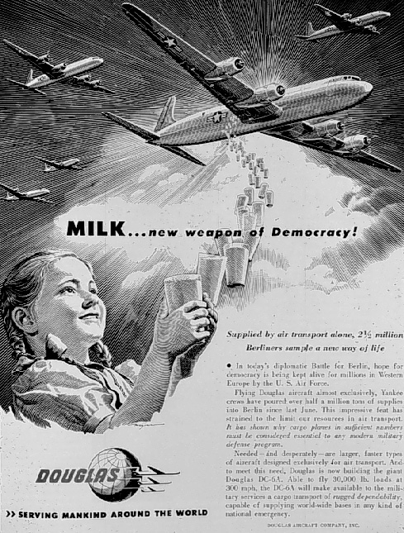
Do Now: What do you think is the message of this poster?

- What does the US conclude in 1848 about the Soviet Union?

- What is the response?

- Describe the Berlin Airlift:

- Summarize the video in 2-3 sentences:

- What does NATO stand for? What is it’s purpose?

- What was the Warsaw Pact?

- Who led Communist forces in China against the government?

- What was the US response? Was it successful?

- Summarize the US policies and status of Communism after the fall of China:

Critical Thinking: How do these events illustrate or serve as examples of the US policy of containment?

