Bill Clinton Activity Overview
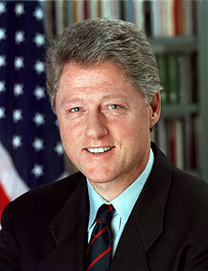
Overview: You will be watching a 3-day documentary on the presidency of Bill Clinton made by PBS. Afterwards, you are going to write a 2-page “Legacy of Bill Clinton” article outlining his achievements prior to and during his presidency. Your article should include information on his presidency, personal life, scandals, and pre-Presidential career.

You should be taking notes throughout the film, and I have provided you with a graphic organizer to help organize your notes.

THIS WILL COUNT AS A QUIZ GRADE AND IS DUE ON WED., JUNE 5th.

THE CLINTON YEARS (PBS)

Personal Life | Political Career

