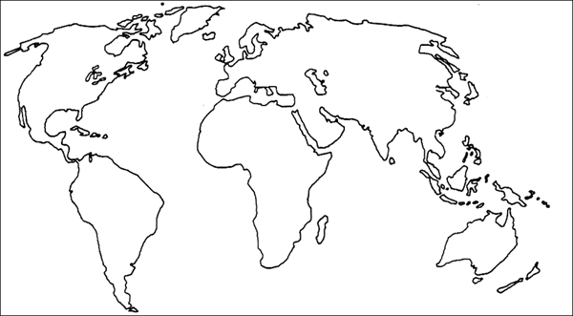
Reasons for Immigration
Push Factors | Pull Factors

Key:

