Chapter 6: Federalists and Republicans (The New Nation)
Study Guide: Mr. Collison US History I

Key Terms to Know:

Cabinet
Bonds
Speculators
Enumerated Powers
Implied Powers
Agrarianism
Most-Favored Nation
Aliens
Sedition
Interposition
Nullification
Judicial Review
Embargo
Impressment
War Hawks
Nationalism

Federalists vs. Republicans (Know this!) – Be able to remember at least 3 differences
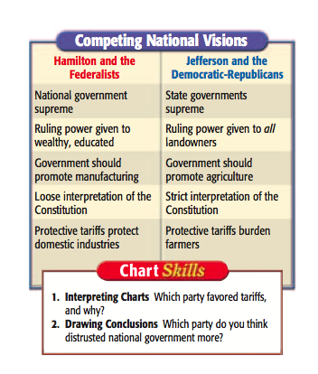

Whiskey Rebellion (Why is it important?)

George Washington’s Major Treaties (What did each one do?):

- Jay’s Treaty

- Pinckney’s Treaty

- Treaty of Greenville

Washington’s Farewell Address (Things he warns against):
- Need for strong government unity
- Avoid political parties
- Stay away from alliances with other countries
- Avoid a large military

Additional Key Topics (Potential Short Answer Questions):

Election of 1800

Louisiana Purchase

Lewis and Clark

War of 1812 battles

Treaty of Ghent and the Battle of New Orleans

