Famous Reformers Presentation

Between the years 1800-1860 there was a plethora of social, political, and religious change in the US. People fought for equal rights, better conditions, and the end of inequities. These changes were widespread, but were spearheaded by individuals, people who risked everything to create reform. For this activity, we are going to be focusing on heroes from two specific movements, women’s rights and abolition.

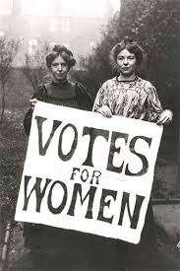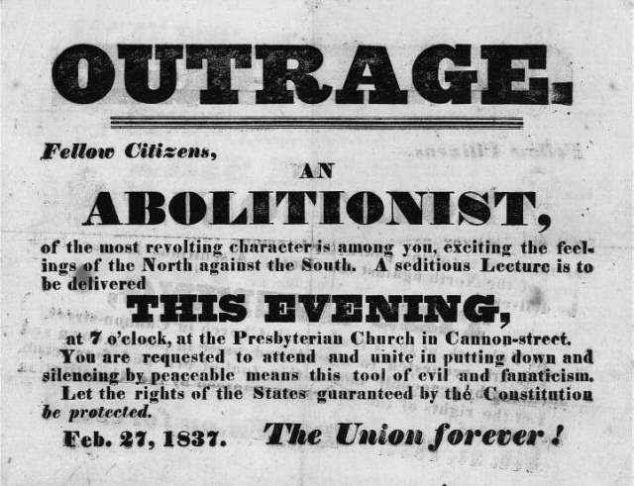

Your Task: You and partner will prepare a short presentation (5 mins. max) on a famous reformer of that time period. You will research some basic background information, but mostly their achievements and role in the movement.

Questions your PowerPoint should answer (These are some, NOT ALL, the information that should be included):

- What was their background?
- What were they fighting for and how did they fight for it?
- What were their major achievements and/or what were they known for?

Reformers to choose from (Only group per person):

- Frederick Douglas
- William Lloyd Garrison
- Sojourner Truth
- Harriet Tubman
- Theodore Wild
- Susan B. Anthony
- Margaret Fuller
- Lucretia Mott
- Elizabeth Cady Stanton

You will present these PowerPoints to your classmates on Wednesday/Thursday of next week, and will have a quiz on all of them Friday. (I will elaborate on this more Monday)

Mr. Collison’s super smart suggestions:
- Do your PowerPoint in Google Drive so you can work on it without meeting in person over the weekend. (I can show you how to do this)
- Use multiple sources

This will count as a QUIZ grade.

 | 5 | 3 | 1
Information/Accuracy | All the information in the presentation is accurate, and the major questions about the reformer are answers. | There is a lot of information, but it’s missing the most important things (Impact on reform, achievements, etc.) | There is very little information in the presentation
PowerPoint | The PowerPoint is well organized, easy to read (NO BIG PARAGRAPHS of Test,) and has relevant pictures on each slide. | The PowerPoint is well organized, but there are large paragraphs of text, and some slides are missing pictures. | The PowerPoint is not organized very well and doesn’t have many pictures.
Presentation | Students present their topic clearly and concisely. They are not standing in front of the slides/projector or just reading off the slides. | Students present the topic clearly and concisely, but are mostly reading from the slides. | Students do not present.
Collaboration | There is clear and obvious collaboration between partners. | Students do not do much in class, and it’s clear there wasn’t much collaboration. | Students get nothing done in class, and one person did the whole project.

