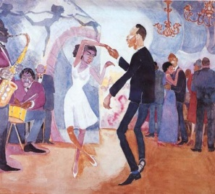
The Roaring 20’s: The Harlem Renaissance

What was the Harlem Renaissance?
-An influential and historically creative period that redefined African-American culture
-Began shortly after World War I, 1920’s
-Harlem, New York City – “the heart and soul of African American renaissance”
-Consisted of writers, artists, and intellectuals from the south
-Known as the “New Negro Movement”

African American’s Role in the Harlem Renaissance
-People that came from Caribbean and Africa began to migrate to Harlem, NYC
-Blossoming of African American culture; mostly in creative arts, literature, music, theater, and visual arts.
-Most influential movement in African American literary history.

Literature
-Langston Hughes – famous writer/poet during Harlem Renaissance
-First published in “The Crisis” in 1921; signature poem “The Negro Speaks of Rivers.”
-His life and work was a huge influence on black culture during Harlem Renaissance.
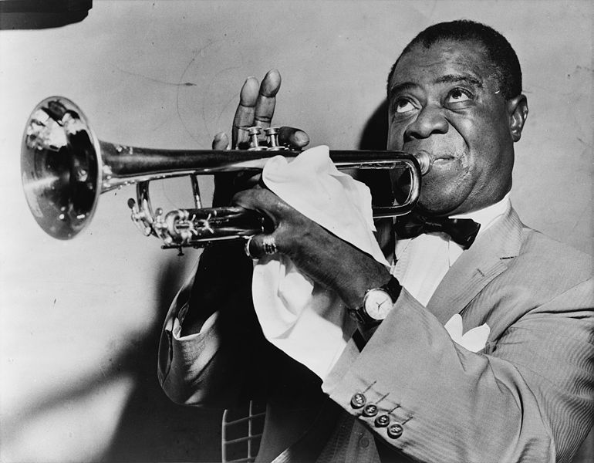
Music
-Harlem Renaissance is popular for the music it produced.
-Best big band Jazz musicians in the world.
-Music created art that reflected the African American community
-Famous jazz and blues singers included Billie Holiday, Duke Ellington, and Louis Armstrong

Impact of the Harlem Renaissance
-Brought African Americans together and glorified the traditions of black culture
-African American artists and musicians gained attention of whites and promoted ideas like racial integration
-Put African Americans in a happier place

