Activity 2: Primary Source Excerpts

Excerpts from John Ross's words to delegates of the Iroquois League:
"Brothers: The tradition of our Fathers . . . tells us that this great and extensive Continent was once the sole home of our race. . . . Ever since [the whites came] we have been made to drink of the bitter cup of humiliation; treated like dogs . . . our country and the graves of our Fathers torn from us . . . through a period of upwards of 200 years, rolled back, nation upon nation [until] we find ourselves fugitives, vagrants and strangers in our own country. . . .

"The existence of the Indian Nations as distinct Independent Communities within the limits of the United States seems to be drawing to a close. . . .”

Excerpts from Andrew Jackson's Seventh Annual Message to Congress, December 7, 1835

"All prior experiments for the improvement of the Indians have failed. It seems now to be an established fact they cannot live in contact with a civilized community and prosper. Ages of useless attempts have at length brought us to a knowledge of this principle of intercommunication with them. . . .

"The moral duty of the Government of the United States is to protect and if possible to preserve and the scattered remains of this race which are left within our borders. As a result, an extensive region in the West has been assigned for their permanent residence or homes. It has been divided into districts and allotted among them. . . .

“The pledge of the United States has been given by Congress that the country destined for the residence of this people shall be forever "secured and guaranteed to them."

"A country west of Missouri and Arkansas has been assigned to them, into which the white settlements are not to be pushed.”

Answer the following questions:

- Who do you think each speaker sided with? (Underline words that prove your point)

- What does Ross say has happened to other Indian groups?

- Why does Jackson say the Indians need to be removed?

- Would you support Jackson in his removal of the Indians? Why or why not? (2-3 sentences)

Name__________________________________ Date______________ Period________

Trail of Tears and Indian Removal Act
Handout #2

Activity 1: Map Activity

Using the map on page 270, color the following details:
- The location of the major tribes that were removed
- The paths they marched or were forced to march
- The New Indian Territory
- The Trail of Tears
BE SURE TO INCLUDE A MAP KEY AT THE BOTTOM

USA 1830

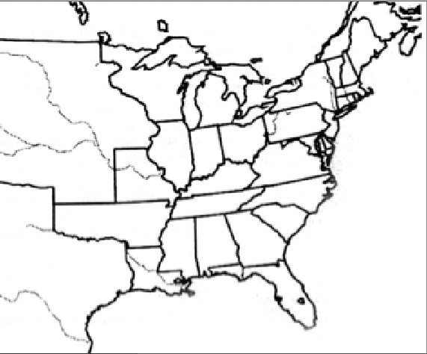

Key:

