Name________________________________________________ Date______________________ Period______
Manifest Destiny (9-1)

Do an I See/It Means on the image below:
John Louis O’Sullivan claimed, it was the “Manifest Destiny of Americans to overspread the continent allotted by Providence”
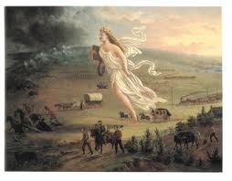

I SEE | IT MEANS
Analysis: Do you think the US was right to take over the rest of the land? Why or why not?

