Quiz Review Sheet (Chapter 10, Sections 1-2 and part of 3)

Key terms and people to know:

Wilmot Provisio

Popular Sovereignty

Conscience Whigs

Cotton Whigs

Free-Soil Party

“Forty-Niners”

Secession

Fugitive Slave Act

Uncle Tom’s Cabin
Harriet Tubman

Underground Railroad

Transcontinental Railroad

Gadsden Purchase

Kansas-Nebraska Act

Charles Sumner

Andrew Butler

Republican Party

Key themes to know:

The Compromise of 1850 and the resolutions for each side
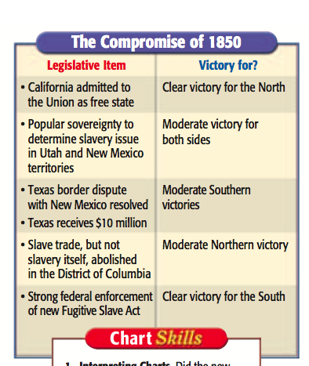

What was “Bleeding Kansas”?

Why were Uncle Tom’s Cabin and the Underground Railroad so important?

What was the caning of Charles Sumner?

