Test Review Chapter 10

Wilmot Provisio

Popular Sovereignty

Conscience Whigs

Cotton Whigs

Free-Soil Party

“Forty-Niners”

Secession

Fugitive Slave Act

Uncle Tom’s Cabin

Harriet Tubman

Underground Railroad

Transcontinental Railroad

Gadsden Purchase

Kansas-Nebraska Act

Charles Sumner

Andrew Butler

Republican Party

Dred Scott

James Buchanan

John Brown (His Raid)

Insurrection

Abraham Lincoln

Crittenden’s Compromise

Major Events between the North and South that made them hate each other

Missouri Compromise

Compromise of 1850

Wilmot Provisio

Fugitive Slave Act

Uncle Tom’s Cabin

The Underground Railroad

“Bleeding Kansas”

Caning of Charles Sumner

Dred Scott Decision

John Brown’s Raid

Abe Lincoln’s Election

Charts and Images that are Important

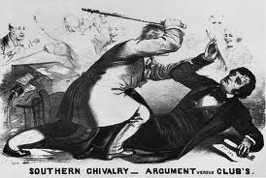

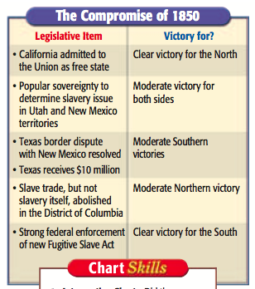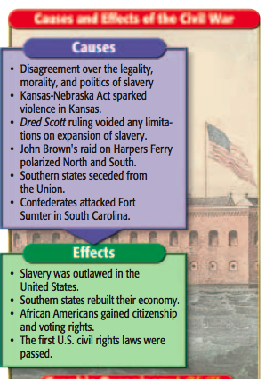

Possible Essay Topics:

- Events that led to the Civil War.
- Why did the North and South hate each other?

