Rise of the Sunbelt (1950-1980)
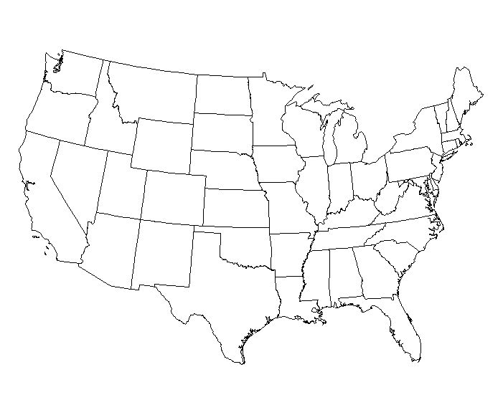
Conservatism Gains Support (33.1)

Sunbelt Conservatism | Suburban Conservatism | The Religious Right

