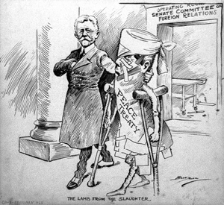

I See | It Means
Analysis (4-6 Sentences):

