Name ____________________________________ Date __________ Period ________

World War II Battles Packet

Day 1:
- On page 743, read through ‘Fall of Philippines’ section and answer the following questions:
- Who was the commander of American troops in the Philippines?

- How long were American troops able to hold out against the Japanese?

- What promise did MacArthur make from Australia?

- What was the Bataan Death March?

- Describe the pictures below. Both are about the Bataan Death March.

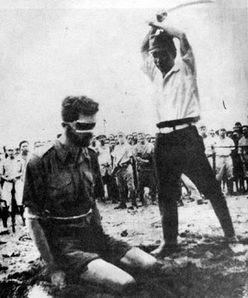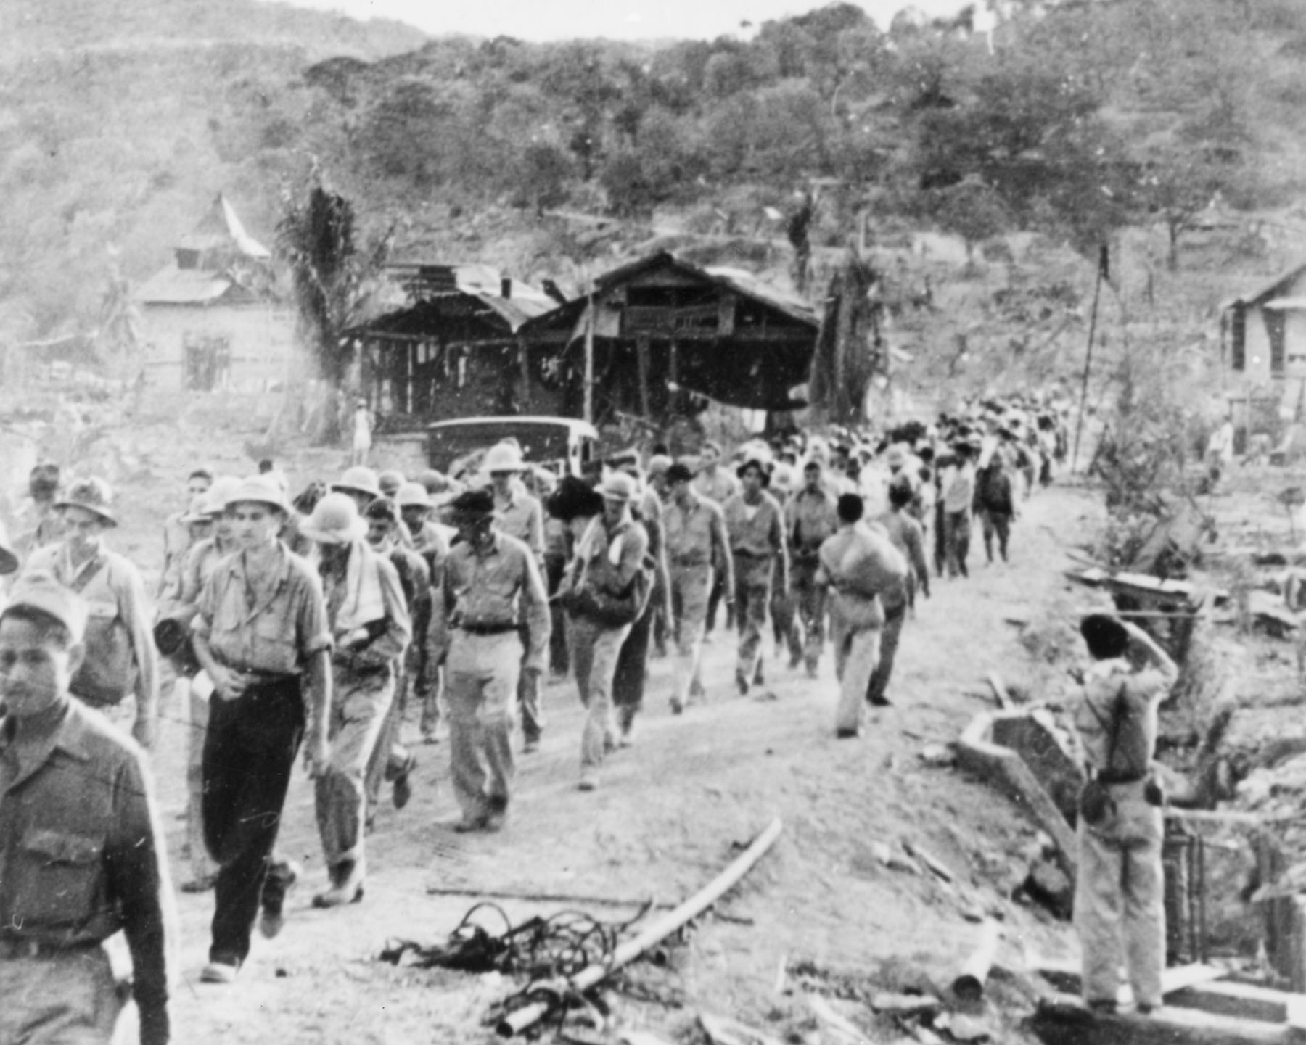

- On page 743, read through ‘The Doolittle Raid’ section and answer the following questions:
- Roosevelt wanted to bomb Tokyo, but what problem did he have?

- What was the plan he eventually came up with?

- Was it successful?

- After the Doolittle Raid, Japan changed their strategy. The realized that the American fleet in the South Pacific needed to be destroyed and they needed to cut American supply lines with Australia. Their plan was to draw American fleets into battle by attacking Midway. First, they needed to attack New Guinea to cut the supply lines, while the rest of the fleet prepared for Midway.

On the map below, complete the following activities:
- Shade in Australia (with a pencil or colored pencil) – Write ‘American Supplies’ beside it
- Shade in New Guinea a different color – Japan’s first attack
- Circle Coral Sea and label it “AMERICAN VICTORY”– At this battle, American forces were able to stop Japanese advances and force them to retreat.
- Put a square around the Island of Midway – American forces intercepted transmissions of a Japanese attack, and the US prepared for an ambush. US Navy/Air Force destroyed Japanese fleet and dealt a HUGE blow.
- Write TURNING POINT next to Midway.

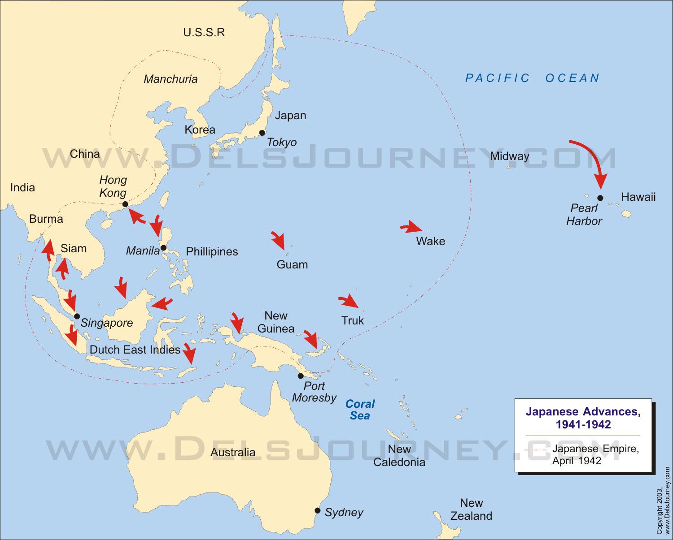

- On page 745, read through ‘Turning Back the German Army’ and ‘The Struggle for North Africa’ section and answer the following questions:
- Roosevelt desperately wanted to get troops to Europe, but Winston Churchill urged caution. Why?

- What did they do instead?

- Define Periphery.

- Where does FDR decide to invade?

- Why is the Suez Canal/Egypt important to Britain?

- Who is leading the American Army in North Africa?

- What happened at the Battle of Kasserine Pass?

- The Battle of Stalingrad (http://www.history.com/topics/world-war-ii/battle-of-stalingrad)

Stalingrad was the turning point of the war in Eastern Europe. Hitler wanted Stalingrad and refused to accept defeat. Stalin refused to give in and surrender the city named after him. It was a costly battle, claiming over 2,000,000 casualties (Civilian and Military) and last over 3 months. Hitler’s army was decimated and never was the same.

Below are quotes about Stalingrad. For each quote, summarize them in your own words.

"December 26. We’ve eaten all the horses. I’d even eat cat: cat meat can be tasty. The squaddies look like corpses or zombies, searching for anything to eat. They don’t even try to duck from the Russian shells – they haven’t the strength to run or hide." Wilhelm Hoffman, Diary of German soldier

"My dear brother! Sorry about the messy handwriting, my hands are frostbitten and my head’s confused. We’ll never get out of here. The breakthrough won’t happen. We’re all dead here – it’s just that we don’t decompose, because of the Russian frost." Helmut Quantz, OberLeutnant, January 24

"The siege of September 13, 1942 to January 31, 1943 will inspire forever the hearts of all free people. Their glorious victory stemmed the tide of invasion and marked the turning point in the war of the Allied nations against the forces of aggression." Franklin D Roosevelt, congratulating Joseph Stalin on the soviet Victory at Stalingrad, 1944

"For Germany, the battle of Stalingrad was the biggest defeat in its history; for Russia, it became its greatest victory. Russia gained the right to be called a great European power near Poltava [in 1709], while Stalingrad was the beginning of its transformation into one of the two greatest world powers." Hermann Doerr, German General, post-war memoirs

Summarize the 3-minute video on Stalingrad:

Day 2:
- Do Now: On page 755, read and summarize An American Story.

- Answer the following questions based on the PowerPoint.
- What did FDR and Stalin agree to in Tehran?

- What was the code-name for the mission?

- How many of each of the following was needed for the invasion?
  - Troops:

  - Ships:

  - Paratroopers:

- Once you watch the Saving Private Ryan scene, answer the following questions:

- What obstacles were the soldiers facing with the landing?

- Describe what you think it was like for the soldiers on the beaches.

- Do you think this type of invasion was worth the loss of life?

Day 3:

Do Now: Match each battle with a quote that best describes something about it.

    - Fall of the Philippines
    - Battle of Midway
    - Stalingrad
    - D-Day

- ______ “I said, to the people of the Philippines whence I came, I shall return. Tonight, I repeat those words: I shall return!”
- ______ “Every man who set foot on Omaha Beach that day was a hero”
- ______ This battle “put an end to the long period of Japanese offensive action” (Turning Point)
- ______ “The street is no longer measured by meters but by corpses...”

A. Answer the following questions based on the PowerPoint:

- What is an amphatrac?

- Where does MacArthur return?

- What battle ended up being the biggest in Navy history?

- What were Kamikaze pilots? What did they do?

B. Highlight/Underling the major information from these excerpts on the Battle of the Bulge.

The Battle of the Bulge was a major battle in Europe during World War II. It was Germany's final attempt to drive the Allies off of mainland Europe. Most of the troops involved on the Allied side were American troops. It is considered one of the greatest battles ever fought by the United States military.

When was it fought?

After the Allies had freed France and defeated Germany at Normandy, many thought that World War II in Europe was coming to an end. However, Adolf Hitler of Germany had different ideas. Early in the morning on December 16, 1944 Germany launched a major attack. The battle lasted for around one month as American forces fought back and kept Germany's army from overrunning Europe.

What happened?

When Germany attacked they used over 200,000 troops and nearly 1,000 tanks to break through the US lines. It was winter and the weather was snowy and cold. The Americans were not ready for the attack. The Germans broke through the line and killed thousands of American troops. They tried to advance quickly.

The Germans had a good plan. They also had English speaking German spies drop in behind the Allied lines. These Germans were dressed in American uniforms and told lies to try and confuse the Americans so they wouldn't know what was going on.

C. In 2-3 sentences, summarize the following pictures:

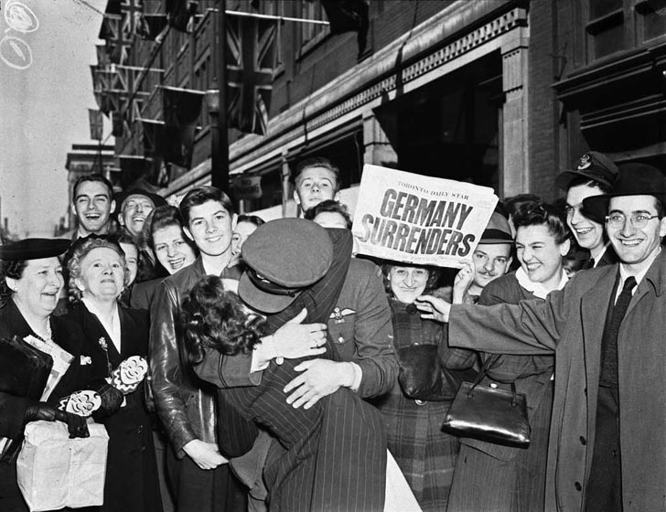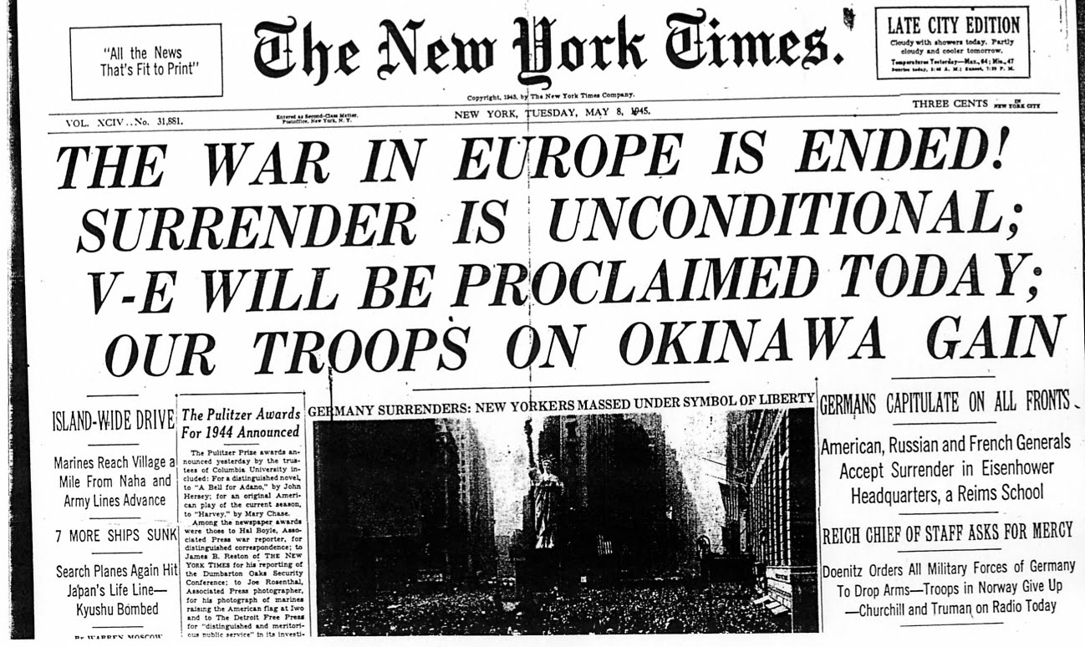

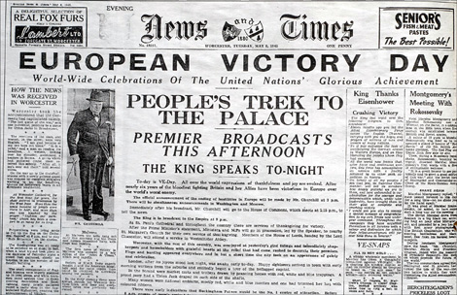

Final Question: What do you think V-E Day means? (Look up in Chapter 25 if you don’t know)

Day 4:
World War II in Colour: Victory in the Pacific

Overview: The video clips we will watch provided an excellent insight into the two major battles in the Pacific, Iwo Jima and Okinawa, as well as the tactics used by the Americans on the Japanese. (2:30 – 12, and 15:15 – 32 min)

As you watch, please answer the following questions:

- Why did the US want to take Iwo Jima?

- Describe the invasion/landing at Iwo Jima:

- Why do you think the photo at the top of Iwo Jima is so iconic?

- What did the US try as an alternative to invading Japan? What did it do?

- Why wasn’t strategic bombing practical?

- Describe the fire bombing (incendiary bombs):

- As strategic bombing failed, what seemed inevitable? Where did they focus their attack?

- Describe the battle of Okinawa (Weapons, tactics, resistance, etc.):

- What did Okinawa show the Americans?

Critical Thinking: From what we’ve seen and learned so far, how was the fighting in World War II different or similar to the carnage of World War I? Do you think it was more violent? Why or why not?

